**Project 4 – Design**

“Bringing sea turtle conservation efforts to the digital age”

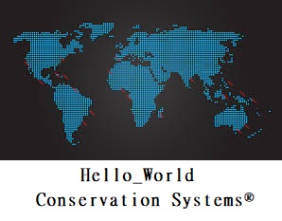

Group Project

IT 320 Fall 2018

Western New England University

Professor Robert Waltz

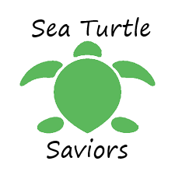

Seth Ayers: Author, Editor

Kurt Gallo: Artist, UX Engineer

Brian Snyder: Concepts, UX Engineer

Tim Seibert: Concepts, UX Engineer

Angelo Rivieccio: Concepts, UX Engineer